**MANAV RACHNA INTERNATIONAL INSTITUTE OF RESEARCH AND STUDIES**  
School of Computer Applications

**RELATIONAL DATABASE MANAGEMENT SYSTEM BSCIT-DS-403 PP**

**NAME – Bhavnish koli ROLL NO – 23/SCA/Bsc-IT/002**

**QUES - 1** Create the following tables  
 Customer

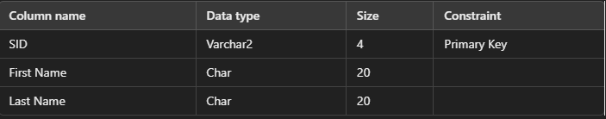

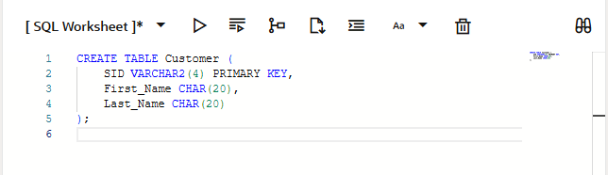

Orders

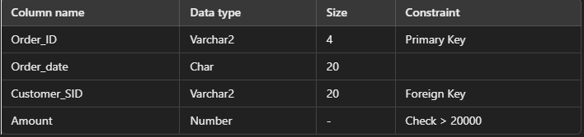

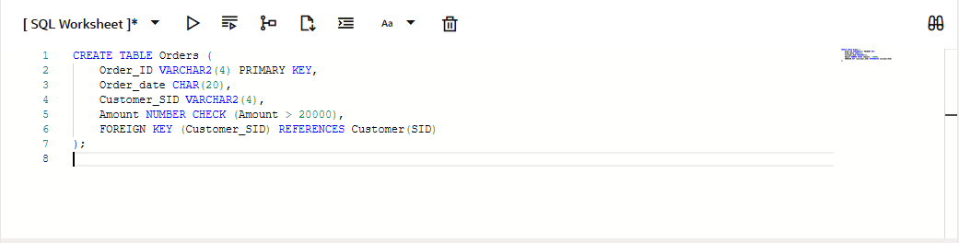

QUES-2 **Insert five records for each table**

Add five records into the **Customer** and **Orders** tables.

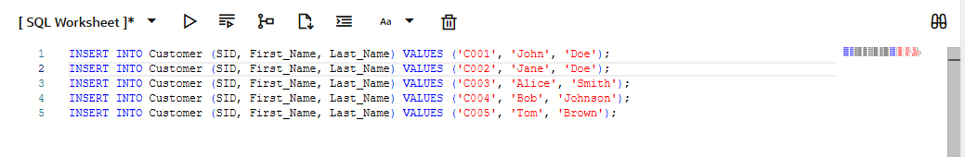

**3. Define Foreign Key Relationship**

* **Customer_SID** column in the **Orders** table is a **foreign key** pointing to the **SID** column in the **Customer** table.

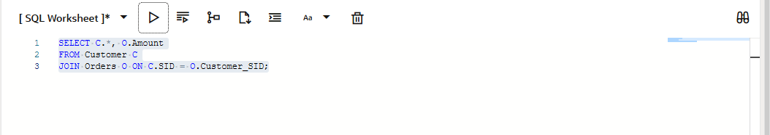

**4. Insert five records for both tables**

* Insert five records into both **Customer** and **Orders** tables.

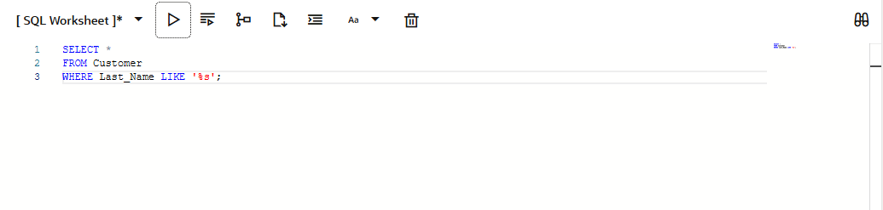

**5. List the details of the customers along with the amount**

* Retrieve customer details along with their **order amount**.

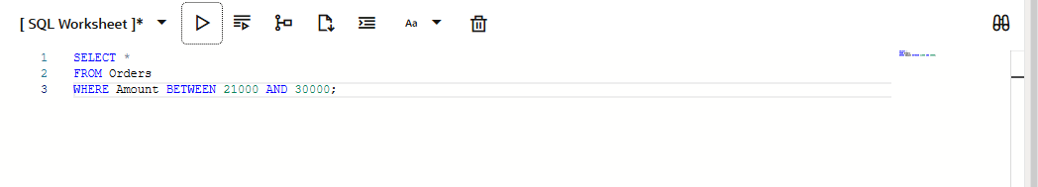

**6. List the customers whose names end with "s"**

* Fetch customer names that end with the letter **"s"**.

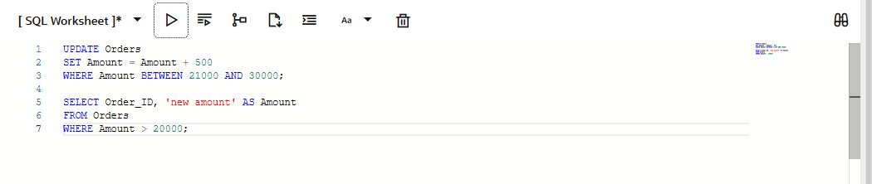

**7. List the orders where the amount is between 21000 and 30000**

* Fetch orders where the **amount** falls between **21

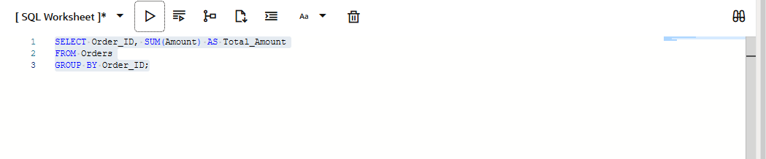

8. List the orders where the amount is increased by 500 and replace it with the name "new amount".

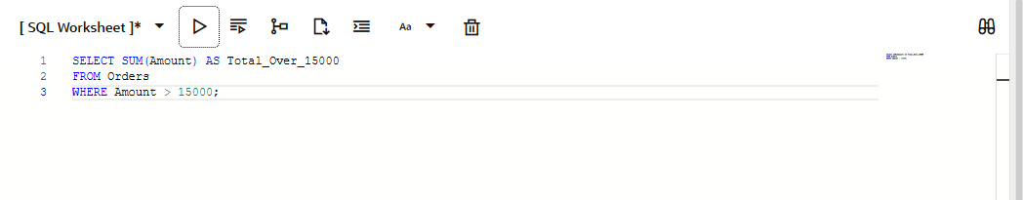

9. Display the order_id and total amount of orders.

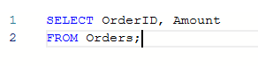

10. Calculate the total amount of orders that have more than 15,000.

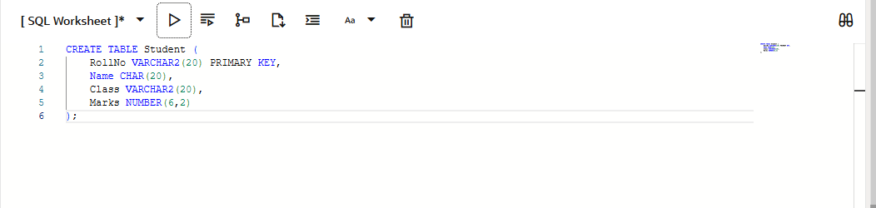

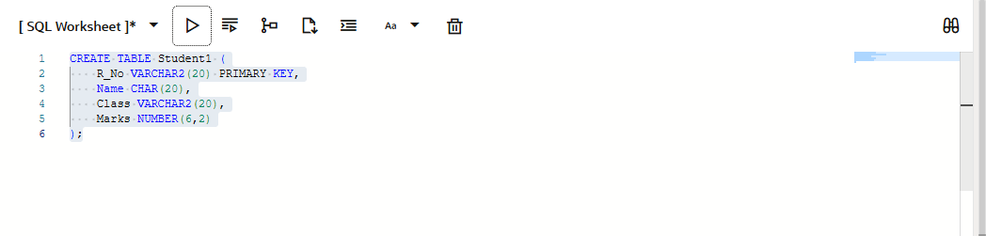

11. Display all the string functions used in SQL.

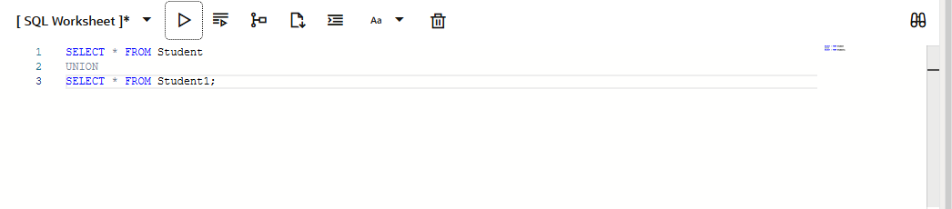

**12. Create the following tables**

* Student (RollNo, Name, Class, Marks)
* Student1 (R_No, Name, Class, Marks)

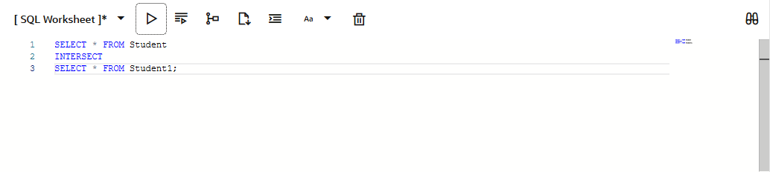

13. Display all the contents of student and student1 using the UNION clause.

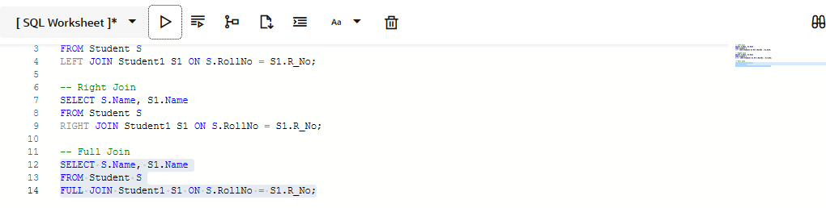

14. Find out the intersection of student and student1 tables.

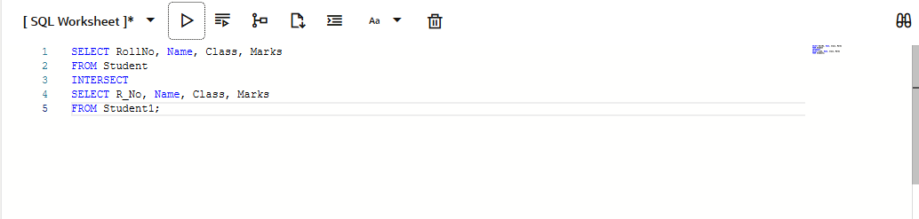

15. Display the names of student and student1 tables using LEFT, RIGHT, INNER, and FULL JOIN.

